FEATURES
- 22 Gauge metal housing with matt white paint
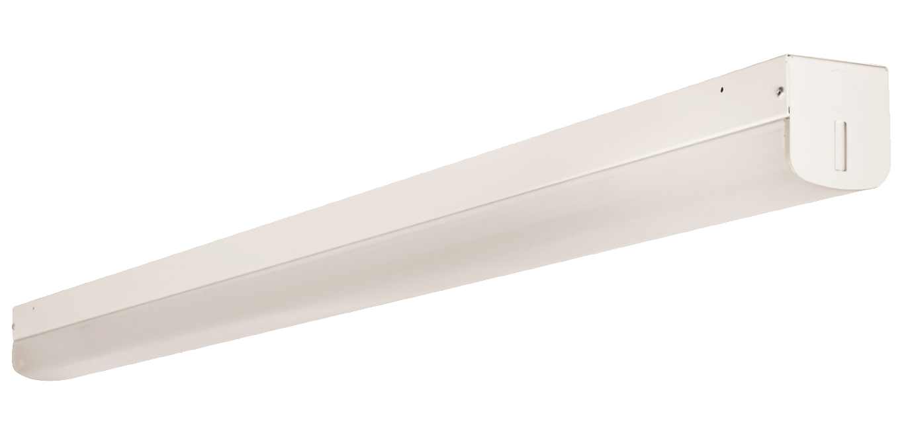
- Smooth PMMA cover lens
- High efficacy meets premium;
- Lens & LED board build-in-one design
- Suspension and surface mount option
- Wattage & CCT selectable
- 5 Year warranty
- DC 12V Auxiliary

Applications
- Parking lot
- Supermarket
- Corridor
- Retail spaces
- Warehouses

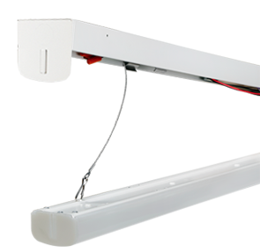
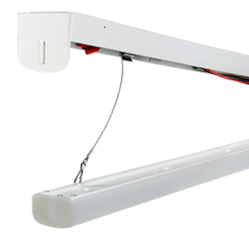

Ordering Information
Name | Length | Wattage | Dimming | Driver | CCT | Backup | Sensor
MLSN | 2:2FT | 22  Or  20/24/28 | /D10:0-10V | /U:120-277V  /W: 120-347 | 35-40-50 | Blank: None | Blank: None
MLSN | 4:4FT | 22/28/36/44 |  |  |  | Battery Backup | Sensor
MLSN | 8:8FT | 44/58/68
 | 8:8FT | 48/68/90
Example: MLSN4-22/28/36/44/D10/U/35-40-50/MS
( covers 22/28/36/44W 4FT 120-277V multi-CCT with motion sensor)

specifications
Model | MLSN2 | MLSN4 | MLSN8
Wattage | ( Cover 22W)  (Cover 20/24/28) | (covers22/28/36/44W) | (Covers 44/58/68W)  (Covers48/68/90W)
Voltage | 120-277V  120-347V
LM/W | >130 @4000K
CCT | 3500K-4000K-5000K
CRI | >80
L70/L90 | 100,000/40,000h
Beam Angle | 120°
Dimension(mm) | 610x68.8x65.5 | 1183.6x68.8x65.5 |  | 2357.6x68.8x65.5
Note: Actual performance may differ as a result of end-user environment and application.
All values are design or typical values, measured under laboratory conditions at 25 °C.
Specifications subject to change without notice

photometric data
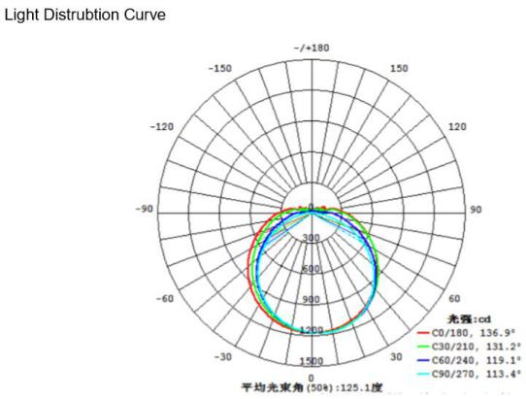
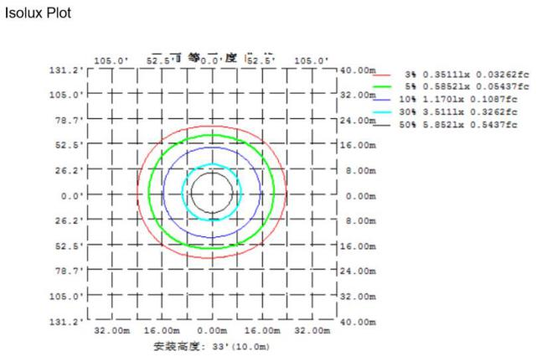

V-Hook | Aircraft cable | Chain | Joiner bracket | Backup pack | Motion Sensor
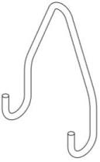  Included | 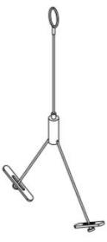 |  | 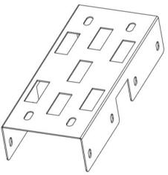 | 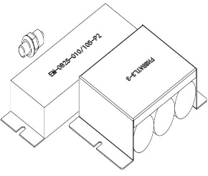 | 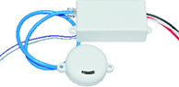

Accessories

