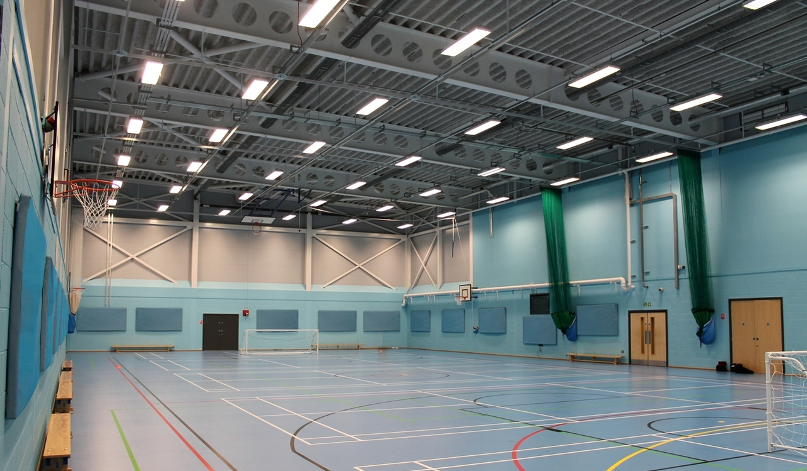
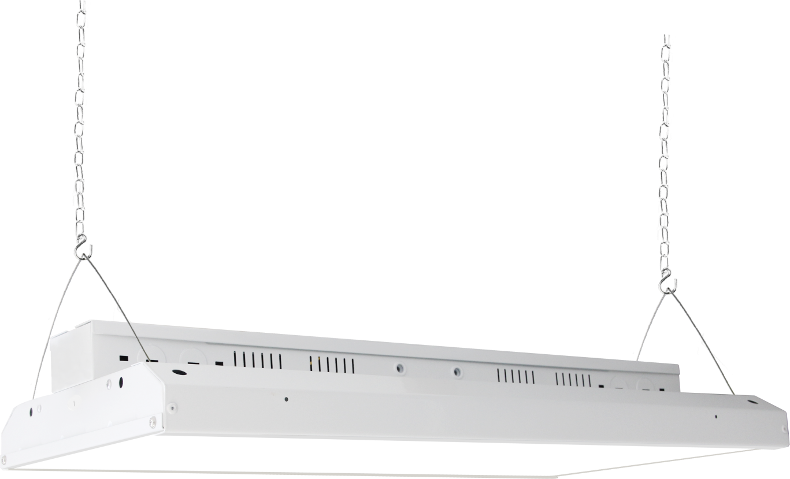
BUILDERS PACK

LINEAR HIGH BAY
ST59 SERIES







DESCRIPTION:
• High luminous efficacy 140lm/w;
• High quality non-isolated driver; 1-10V dimming; Flicker.
• PF >0.90, driver efficiency >87%; THD<20%
• LED Linear high bay lighting is a popular choice in warehouse lighting.
• They are easy to hang with two gribber cables and easy to connect with the junction box right on
back.
• Popular for their wide light distribution, they are a great choice for going LED and saving energy.

APPLICATIONS:
• Designed for warehouses, gymnasiums, and industrial spaces;

SPECIFICATIONS
SKU | Model | Wattage | Size | CCT | Efficacy | Lumens | Input Current
25-31201-xx | ST36-LHB-12-7110-8XX-B | 110W | 1x2' | 4000K | 140 LPW | 15400 lm | Max. 1.10A
 |  |  |  | 5000K | 140 LPW | 15400 lm | Max. 1.10A
25-31202-xx | ST36-LHB-12-7165-8XX-B | 165W | 1x2' | 4000K | 140 LPW | 23100 lm | Max. 1.65A
 |  |  |  | 5000K | 140 LPW | 23100 lm | Max. 1.65A
25-31203-xx | ST36-LHB-14-7215-8XX-B | 225W | 1x4' | 4000K | 140 LPW | 31500 lm | Max. 2.25A
 |  |  |  | 5000K | 140 LPW | 31500 lm | Max. 2.25A
25-31206-xx | ST36-LHB-14-7320-8XX-B | 320W | 1x4' | 4000K | 140 LPW | 44800 lm | Max. 3.20A
 |  |  |  | 5000K | 140 LPW | 44800 lm | Max. 3.20A

Photomeritc
CRI | SDCM | R9 | Duv | Beam Angle
≥80 | ≤4 | ≥0 | ≤0.006 | 90°

Electrical
Frequency | Voltage | Power Factor
50/60Hz | AC 120-277V | ≥0.90

Lifetime [at 120-227V]
L70 Lumen Maintenance Life [Hour] | L90 Lumen Maintenance Life [Hour] | Warranty [Years]
≥50000 | ≥36000 | 5

Technical Requirements
Certifications | UL I CE I FCC I RoHS
THD | ≤20%
Ripple Current | ≤5%
Frequency of LED Current | ≥120Hz
Flicker | Flicker
Electrostatic Discharge [ESD] | 4KV Contact discharge / 8KV Air discharge
Surge Protection | 4KV
Dimming | 1-10V
Sensor | Optional
Emergency Power | Optional
IP Degree | IP20

Operation and Information
Start Time | ≤1 S
Operating Temp. | -4℉~+113℉
Storage Temp. | -22℉~+149℉
Housing / Case [Color, Material] | White, Steel
Optical - Lens [Material] | PC
Mounting / Installation | Pendant Mount / Surface Mount
Environment | Indoor / Suitable for damp location

LAMP CODE DEFINITIONS
Internal Use | Product Code | Size | Wattage | CCT | Version
ST36 | LHB | 12 = 1x2' | 110W | 8XX = 4000K,  4500K,  5000K,  5700K | B
ST36 | LHB | 12 = 1x2' | 165W | 8XX = 4000K,  4500K,  5000K,  5700K | B
ST36 | LHB | 14 = 1x4' | 225W | 8XX = 4000K,  4500K,  5000K,  5700K | B
ST36 | LHB | 14 = 1x4' | 320W | 8XX = 4000K,  4500K,  5000K,  5700K | B

DIMENSIONS

1x2' 110W / 165W
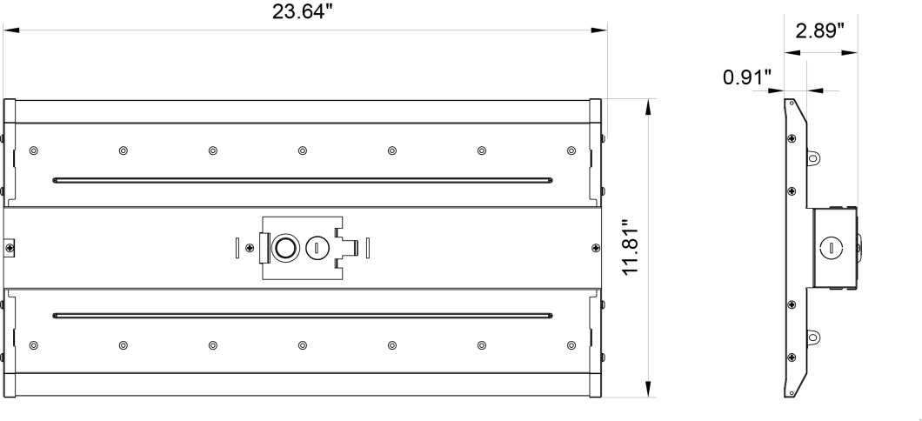

1x2' 225W
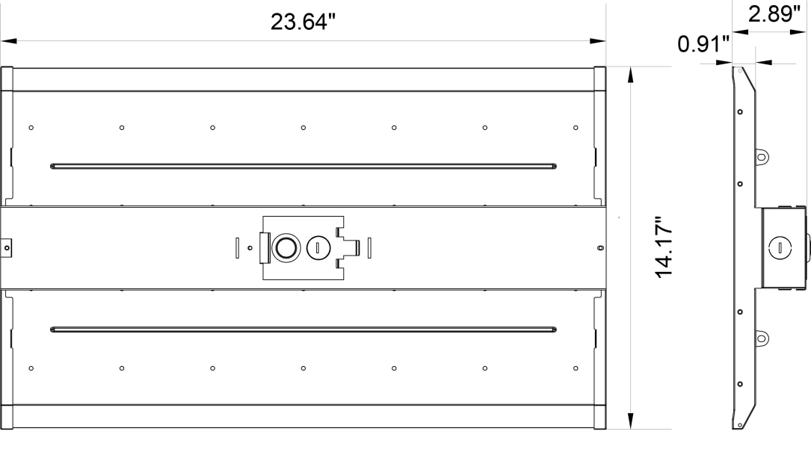

1x4' 320W

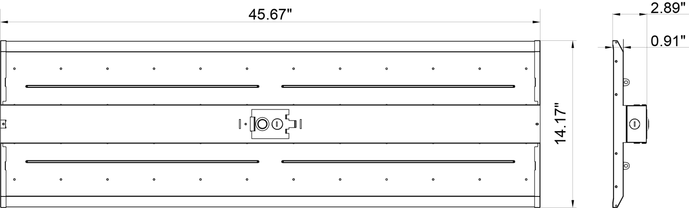

Product Size | Wattage | Long (L) | Wide (W) | High (H) | Net Weight
1x2' | 110W | 23.64'' | 11.81'' | 2.89'' | 13.44 lbs
1x2' | 165W | 23.64'' | 11.81'' | 2.89'' | 13.67 lbs
1x4' | 225W | 23.64'' | 14.17'' | 2.89'' | 17.22 lbs
1x4' | 320W | 45.67'' | 14.17'' | 2.89'' | 29.28 lbs

PACKAGE
Product Size | Wattage | Pcs / Carton | Master Carton Size | Gross Weight | Pcs / Pallet
1x2' | 110W | 2 pcs | 25.39’’ x 9.06’’ x 14.17’’ | 15.03 lbs | 72 pcs
1x2' | 165W | 2 pcs | 25.39’’ x 9.06’’ x 14.17’’ | 15.43 lbs | 72 pcs
1x2' | 225W | 2 pcs | 25.39’’ x 9.06’’ x 16.93’’ | 19.84 lbs | 60 pcs
1x4' | 320W | 2 pcs | 47.44’’ x 9.06’’ x 16.93’’ | 35.27 lbs | 40 pcs

*Package specifications are subject to change without notic

CONTAINER LOADING
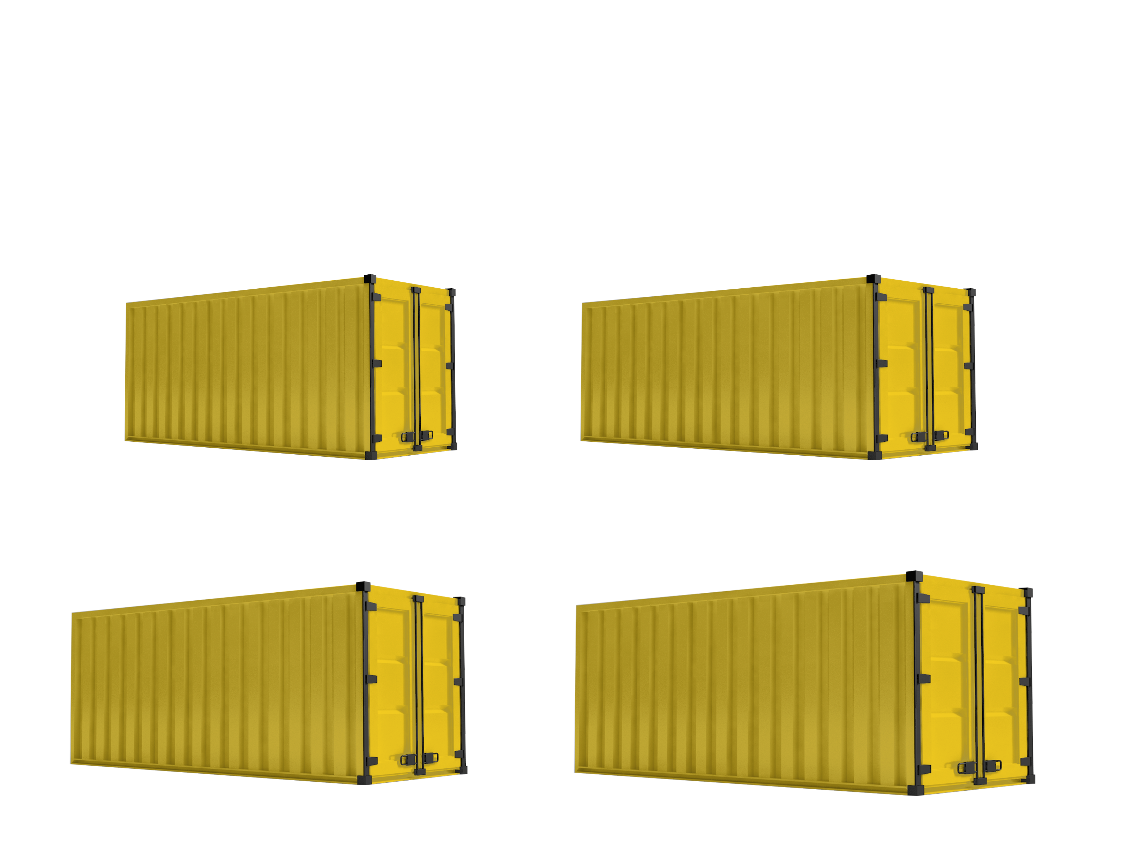

20GP Container 40GP Container
110w | 1010pcs (No Pallet) | 576pcs (Palletized) |  | 110w | 2090pcs (No Pallet) | 1296pcs (Palletized)
165w | 1010pcs (No Pallet) | 576pcs (Palletized) |  | 165w | 2090pcs (No Pallet) | 1296pcs (Palletized)
225w | 840pcs (No Pallet) | 480pcs (Palletized) |  | 225w | 1750pcs (No Pallet) | 1080pcs (Palletized)
320w | 450pcs (No Pallet) | 320pcs (Palletized) |  | 320w | 930pcs (No Pallet) | 720pcs (Palletized)

40HQ Container 45HQ Container
110w | 2500pcs (No Pallet) | 1296pcs (Palletized) |  | 110w | 2800pcs (No Pallet) | 1440pcs (Palletized)
165w | 2500pcs (No Pallet) | 1296pcs (Palletized) |  | 165w | 2800pcs (No Pallet) | 1440pcs (Palletized)
225w | 2100pcs (No Pallet) | 480pcs (Palletized) |  | 225w | 2400pcs (No Pallet) | 1200pcs (Palletized)
320w | 1110pcs (No Pallet) | 320pcs (Palletized) |  | 320w | 1280pcs (No Pallet) | 800pcs (Palletized)

AVAILABLE OPTIONS
SKU | Description | Image
39-93011-A | PIR Sensor Use for Low Altitude | 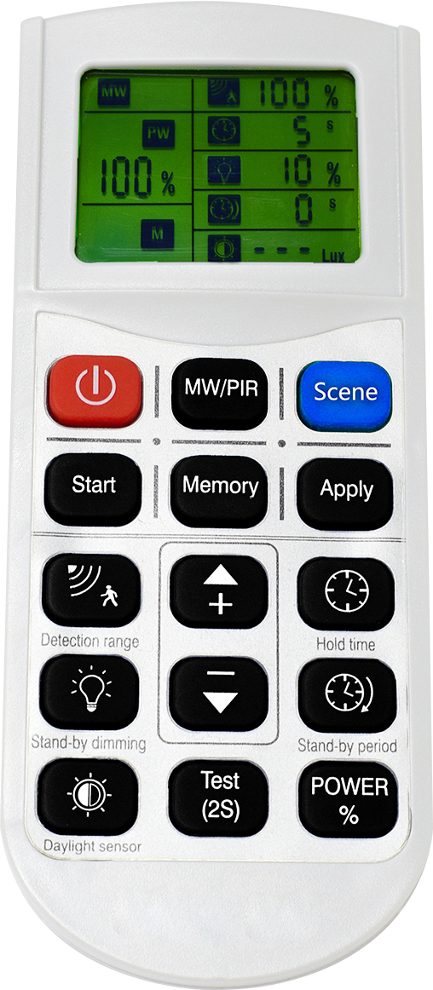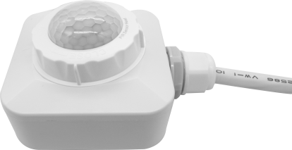
39-93013-A | PIR Sensor Use for High Altitude
39-93017-A | Microwave Sensor Use for Low Altitude | 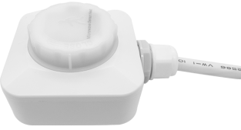
39-93019-A | Microwave Sensor Use for High Altitude
37-31175-A | Surface Mount | 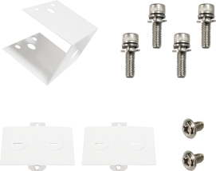
 | Wire guard use 110/165W | 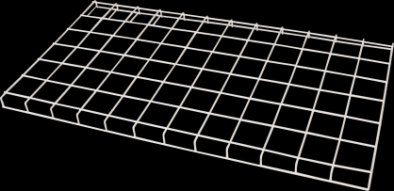
 | Wire guard use 225W | 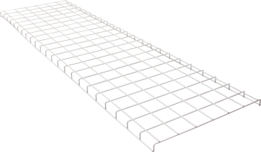
 | Wire guard use 320W | 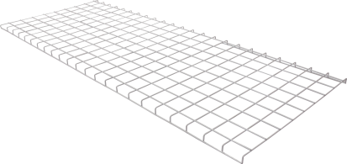
78-20178-A | Remote Control with Standby Functions and Digital Display
44-33005-A | Remote Control with Standby Functions | 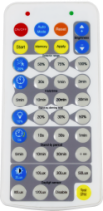
44-33008-A | Remote control On/Off Only | 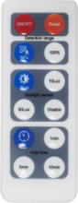
58-92057 | Emergency Power 15w, for 110w/165w LHB | 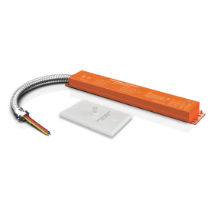
58-92058 | Emergency Power 20w, for 225w LHB
58-92059 | Emergency Power 25w, for 320w LHB

